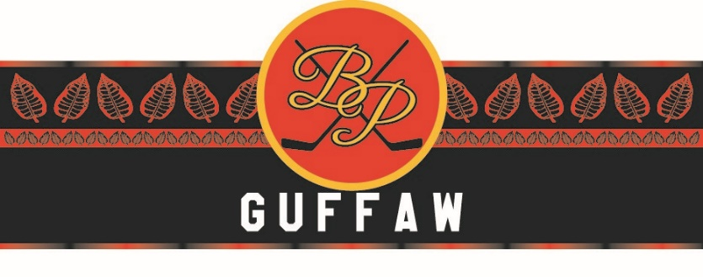
Guffaw® Cigars by Brian Propp
Manufactured by Vivonte’ Cigars, Puerta Plata, R.D.
Imported and Distributed by United Tabac

Welcome to “GUFFAW”™… Lets make a little noise!
As my friends know, I have enjoyed the world of cigars for many years. In that time, I came to find that my favorite cigar experiences had some common pieces…a smooth draw…an incredible aroma…and some friends to enjoy it with.

I am pleased and proud to announce that my friends in the Dominican Republic, Vivonte Cigars, in Puerto Plata on the northern coast of the country have developed a “GUFFAW™”- inspired cigar for everyone to enjoy which embodies my experiences and draws us in to deliver an incredible cigar experience.

My friend Glen Hamilton, owner of Vivonte Cigars, and I were talking cigars one day and I suppose my passion was clear. We talked about my time as a professional hockey player, The Philadelphia Flyers, other sports and my cigar experiences. It became clear that a new cigar creation was in our future. I am pleased to announce that through that meeting we have now licensed my trademark GUFFAW™ to Vivonte to bring the idea to reality.
Glen and I worked with some of the finest ingredients in the world to create a blend that is our premium “GUFFAW™” Cigar line. From our Robusto Gordo, a 56 x 5” to our Maduro, the rich wrappers and custom fillers are a blend of the finest secos and ligeros. The result is a wonderful cigar in each of three distinct areas the cigar experience, each with an incredibly smooth and rich flavor.
I am proud to introduce the GUFFAW™ cigar experience to represent the spirit of “GUFFAW™” and the passion with which I played the game of hockey for so many years.
Welcome to the taste of Guffaw™. Celebrate, enjoy and…”Make a Little Noise”… Guffaw™!

Brian Propp

Selections:
Name | Size | Description | MSRP
Limited Edition Gran Robusto | 56 x 5 | A special blend of the finest hand selected Dominican tobaccos featuring a 5 year aged Corojo wrapper Medium body full body | $13.95
Mediano | 56 x 6 | A true medium smoke with a smooth soft taste – Ingredients: Dominican ligeros and secos aged 3 years and featuring a hybrid Cuban seed Havana 2000 premium wrapper | $12.95
Maduro | 56 x 6 | Full bodied smoking at its finest – featuring a unique blend of 3 year old Nicaraguan and Dominican ligeros with a classic Cuban seed seco finished off with a Habana 2000 maduro wrapper | $12.95
Suave | 56 x 6 | A smooth and mild cigar experience featuring a Connecticut Ecuador wrapper with Two Dominican secos and one ligero filler and a Binder of Dominican from Cuban Seed | $12.95
Special Order | 1 | Limited Edition Gran Robusto in Custom Autographed Box of 10 (Limit 2) | $145.00
Special Order | 2 | Sample Pack of 5 in Custom Autographed Box (Limit 5) | $60.00

Point of Sale:
As part of your order we will supply you with two counter-top stand-up point of sale displays and one stand-up floor display depicting the Guffaw brand and Brian to call attention to the new addition to the Guffaw brand.
Event Scheduling:
To assist you in introducing Guffaw to your clients upon the placement of the second 3 bundle order you may request a Guffaw Cigar Night with Brian Propp. Brian will attend the event to showcase Guffaw, meet your clients, talk cigars, hockey and life for an enjoyable 2 hours.
Guffaw® Cigars by Brian Propp
Manufactured by Vivonte’ Cigars, Puerta Plata, R.D.
Imported and Distributed by United Tabac

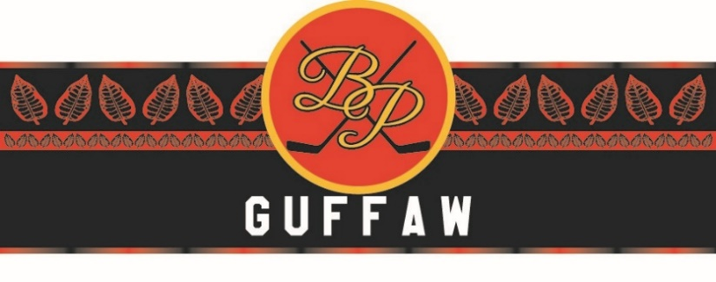
CUSTOMER:
ADDRESS:

PHONE:
CONTACT:
ORDERED BY:
DATE ORDERED:
DELIVERY DATE:

ORDER SELECTIONS:
Name | Size | Description |  | Qty | Total
Limited Edition Gran Robusto | 56 x 5 | A special blend of the finest hand selected Dominican tobaccos featuring a 5 year aged Corojo wrapper Medium body full body | Bundle of 25  $175
Mediano | 56 x 6 | A true medium smoke with a smooth soft taste – Ingredients: Dominican ligeros and secos aged 3 years and featuring a hybrid Cuban seed Havana 2000 premium wrapper | Bundle of 25  $175
Box of 24
$200
Maduro | 56 x 6 | Full bodied smoking at its finest – featuring a unique blend of 3 year old Nicaraguan and Dominican ligeros with a classic Cuban seed seco finished off with a Habana 2000 maduro wrapper | Bundle of 25  $180
Box of 24
$200
Suave | 56 x 6 | A smooth and mild cigar experience featuring a Connecticut Ecuador wrapper with Two Dominican secos and one ligero filler and a Binder of Dominican from Cuban Seed | Bundle of 25  $175
Box of 24
$200
Special Order | 1 | Ltd. Ed. Gran Robusto: Custom Autographed Box of 10 (Limit 2) | $105
 | 2 | Sample Pack of 5 in Custom Autographed Box (Limit 5) | $45
Sub-total Cigars
Sales Tax
(if applicable)
Shipping
Total Order*

Order reviewed and approved by:________________________________. (owner/manager)

* We ask that all orders be paid for upon placement. If special terms are required, please consult with our office so we can assure the best service possible. And thank you for your order.

